**LED STRING ANIMATION**

**CYRS**

Table of Contents

1. Document History 3

1.1. History Table 3

1.2. Status 3

2. Project Description 3

3. Block Diagram 4

4. Features Description 4

4.1. Start-Up Description 4

4.2. Tail Function Description 5

4.3. Turn Indicator(TI) Function Description 6

**PO5_LSAN_ LED STRING ANIMATION**

# Document History

## History Table

|  |  |  |  |
| --- | --- | --- | --- |
| **Version** | **Author** | **Data** | **Change** |
| 1.0 | Hesham - Mark - Mirna. | 23/01/2020 | * Initial creation. |
| 1.1 | Hesham - Mark - Mirna. | 29/01/2020 | * Adding Requirements from 01 to 08. * Block Diagram updated. * Document Layout Updated. |
| 1.2 | Hesham – Mirna | 05/02/2020 | * Requirements 05 and 07 are updated. * Project Description and System Layout is updated. * Header Table inserted. * Status Table inserted. * Details are added to V1.1 changes. |

## Status

|  |  |  |  |
| --- | --- | --- | --- |
| **Version** | **Status** | **Author** | **Date** |
| 1.0 | Draft | Hesham - Mark - Mirna | 23/01/2020 |
| 1.1 | Proposed | Hesham - Mark - Mirna | 29/01/2020 |
| 1.2 | Proposed | Hesham – Mirna | 05/02/2020 |

# Project Description

The project is composed of 3 sets of LED Strings Simulating the animation of LEDs in a Car.

One set is named “Tail” and it simulates the animation of car’s back LEDs while the other 2 sets are named “Left TI” and “Right TI” is simulating the animation of left and right turn indicator in a car.

Each one of the 3 functions operates based on input signals coming from 3 switches named “Tail Switch”, “Left TI” and “Right TI” respectively in addition to “Welcome Mode” which shall operates one of 2 different modes based on the status of the mode switch. System layout is as shown in Figure 1 below.

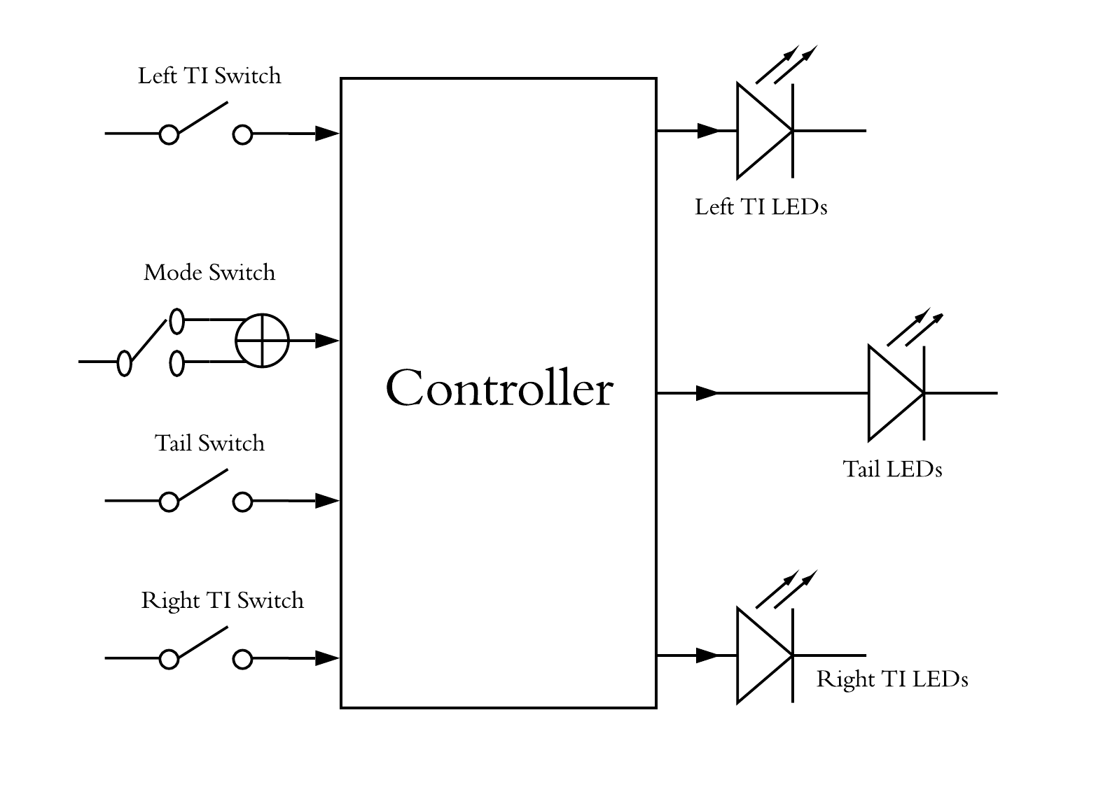

Figure 1: layout of the system

# Block Diagram

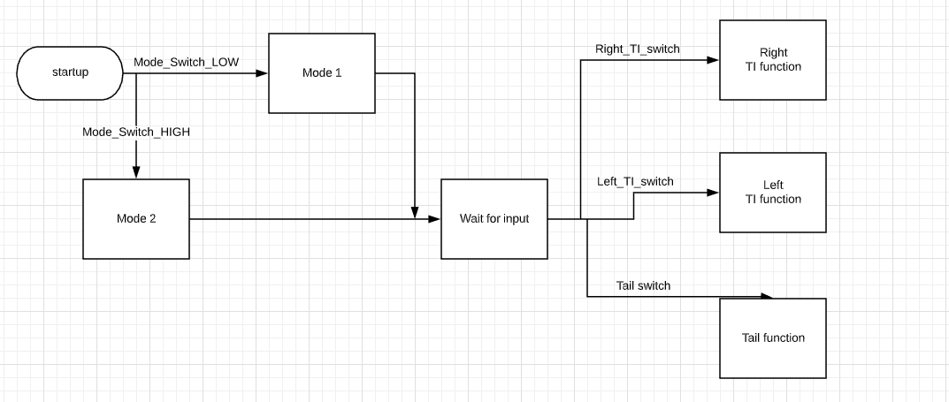

# Features Description

## Start-Up Description

At start up, WELCOME mode shall be one of **2 Modes** and this will be handled according to **mode switch** connected as input signal to the controller, if it's LOW enter **Mode 1** and if it's HIGH enter **Mode 2**. Modes are as the following description:

* **Mode 1:** LEDs shall be ON from L6 to L1, then from R1 to R6 and vice versa, and then all LEDs are ON and OFF.
* **Mode 2:** LEDS from R1 to R6 are ON LED by LED and also the left branch at the same time, and then repeat the scenario again.

**Start Up Requirements:-**

1. **Req_ PO5_LSAN_ LED STRING ANIMATION_01_V01**

When Mode switch is released, this indicates entering WELCOME MODE 1 and LEDs animation shall be as described before in Mode 1.

1. **Req****_ PO5_LSAN_ LED STRING ANIMATION_02_V01**

When Mode switch is pressed, this indicates entering WELCOME MODE 2 and LEDs animation shall be as described before in Mode 2.

## Tail Function Description

Tail function LEDs shall be ON when the Tail signal is HIGH level and shall be OFF when Tail signal level is LOW, activation and deactivation shall be done without any animation so simply ON all Tail LEDs when Tail signal is HIGH and OFF them when it's LOW.

**Tail Requirements:-**

1. **Req_ PO5_LSAN_ LED STRING ANIMATION_03_V01**

When Tail switch is pressed, this indicates that all tail LEDs shall be ON without any animation.

1. **Req_ PO5_LSAN_ LED STRING ANIMATION_04_V01**

When Tail switch is released, this indicates that all tail LEDs shall be OFF without any animation.

## Turn Indicator (TI) Function Description

TI function shall be activated/deactivated according to TI switches signals, LEDs shall be activated LED by LED from R1 to R6 or from L1 to L6 according to Right TI switch or Left TI switch respectively.

**TI Requirements:-**

1. **Req_ PO5_LSAN_ LED STRING ANIMATION_05_V01**

When right TI switch is pressed, right TI function shall be activated and right TI LEDs shall be animated from R1 to R6 and the LED lighting animation scenario shall be as following:-

* R1 (100 ms) > R1+R2(100 ms) > R1+R2+R3(100 ms) > …,etc.
* Then all LEDs shall be turned off.
* Sequence shall be repeated until Right TI Switch is released.

1. **Req_ PO5_LSAN_ LED STRING ANIMATION_06_V01**

When right TI switch is released, right TI function shall be deactivated.

1. **Req_ PO5_LSAN_ LED STRING ANIMATION_07_V01**

When left TI switch is pressed, left TI function shall be activated and left TI LEDs shall be animated from L1 to L6 and the LED lighting animation scenario shall be as following:-

* L1 (100 ms) > L1+L2(100 ms) > L1+L2+L3(100 ms) > …,etc.
* Then all LEDs shall be turned off.
* Sequence shall be repeated until Left TI Switch is released.

1. **Req_ PO5_LSAN_ LED STRING ANIMATION_08_V01**

When right TI switch is released, right TI function shall be deactivated.